This small test is used to identify the relevant data visualization skills we required. Please follow the steps below to generate the required graphs. You may use any visualization tool (except SAS, MS Excel and MS PowerPoint). Tools can be, but not limited to are: PowerBi, R, Python

- Load the attached CSV files into a ‘library’/’repository’.
Import from CSV files
Info_Country.csv
Info_Group X.csv
Info_Group Y.csv
Info_Project.csv
Info_Response Class.csv
Info_X Rank Y.csv
Response 2007.csv
Response 2008.csv
Response 2009.csv
Response 2010.csv

Relationships/model between tables are briefly specified here for your reference (‘test’ represents the library/repository where you loaded the data).
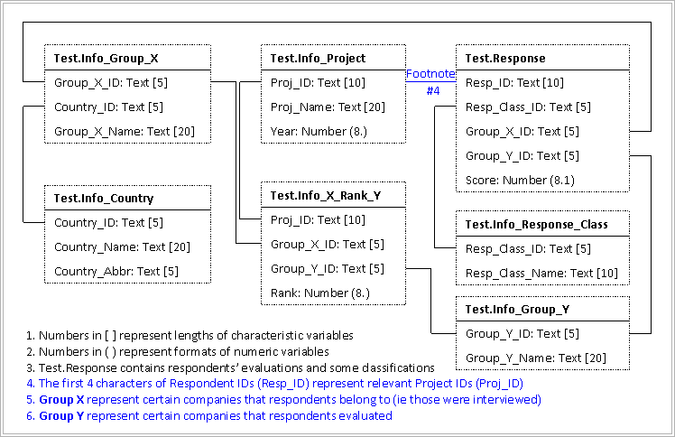

Please pay attention to the footnotes highlighted in BLUE.
Please use ‘Calibri’ as the font for the following graphs and table.

- Produce a visualization of the analysis from the provided data given the descriptions below:

The main dataset to be used here is Test.Info_X_Rank_Y (you will also need several other datasets to know the years and names etc.).

In this analysis, we need find out from 2007 to 2010, how many times GY1, GY2 and GY3 are ranked in each year (shown as numbers under bars on the graph below). And within each year’s bars we’d also like to know what the proportions are respectively that GY1, GY2 and GY3 are ranked as 1st, 2nd and 3rd (shown as percentages within each bars).

Please use ‘#FFDAB9’ as the color for 1st ranked, ‘#ADD8E6’ as the color for 2nd ranked and ‘#FAFAD2’ as the color for 3rd ranked.

Please produce the output to the best you can, applying your knowledge in data visualization.

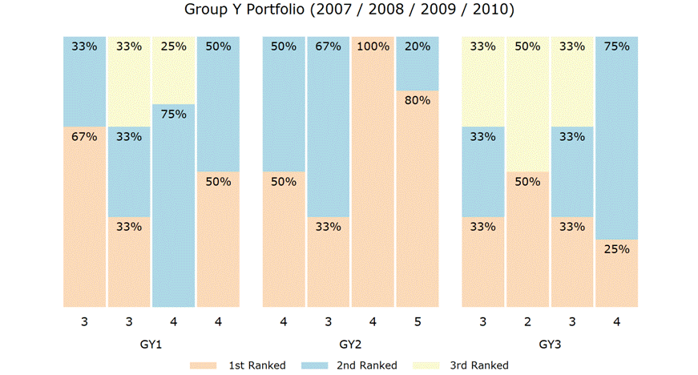

- Produce a data visualization of the analysis similar to the below using the drivers.csv data.

Data details:
  - Year – there are 3 years of data
  - Dot_value – these are the scores/positions (x-axis below) of the companies (dot_label) for each factor in each year
  - Dot_count – number of citations for a company for each factor in each year
  - Dot_label – company abbreviations
  - Fac_order – order of the factors (being 1 at the bottom)
  - Color_outline – outline color of each pie
  - Color_fill – this is a means to identify the companies

Graph description:
- The analysis below shows 2019 only. However, in your dashboard, you may find a way to show data for 3 years.
- Red triangle refers to the score ‘SUN’
- Number in brackets represents the number of citations for ‘SUN’.
- To clarify, there is no need for further calculations coming from the data in drivers.csv

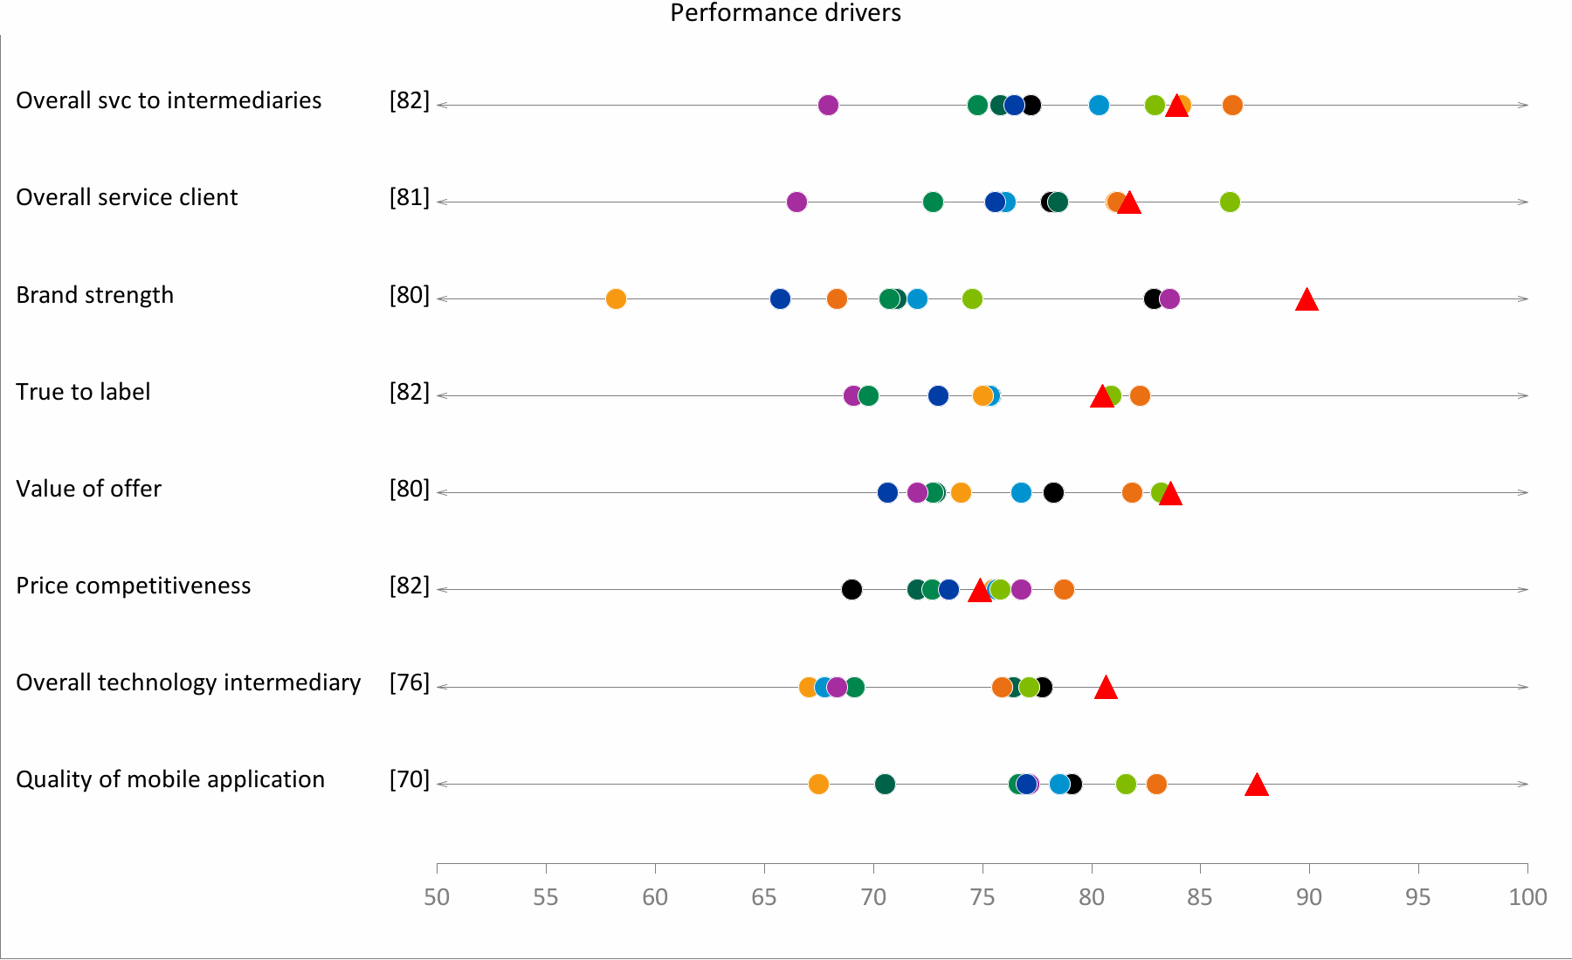

- You are given the flexibility to apply your own style and knowledge in the design to come up with the outputs.
- Please send back all files, codes and projects within 2 days after you receive the test requirements. The time you submit the solutions will be considered when we evaluate them.
- You may use any software and/or tools of your choice – please just let us know what these are.
- Please produce a brief summary describing your work from loading of data, making the model to producing the graphs. Please also mention why you chose the method as well as the relevance of your design to the required analysis.
Please note:

- Reference to the relevant resources (Tutorials, internet, books etc.) is encouraged.
- However, all codes/projects must be produced by yourself.
- If you are not clear about the requirements, you may ask for clarification. Remote communications by email is also an important part of this role.

